# Database Design

**Document Title:** Database Design  
**Activity ID:** M2.5  
**Date:** 17/04/2025  
**Project Team ID:** TP706-S1-Team2   
**Project Team Name**:Team 2

## Database Design

Amazon Review 2023

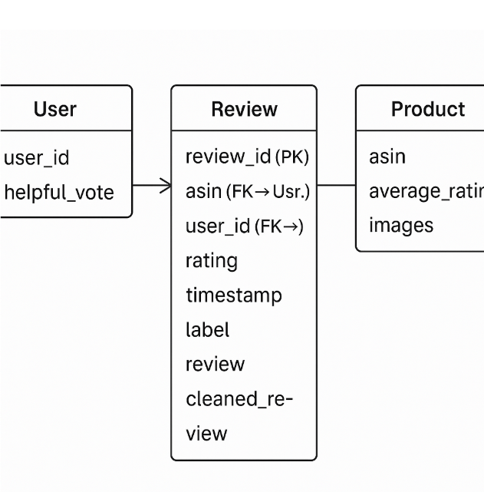

Fake Review Detection Dataset (Small)

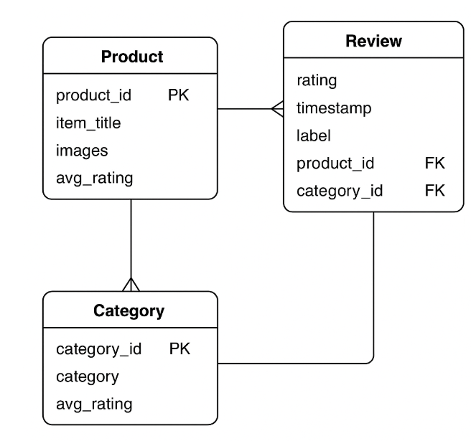

## 2. Table Structure

**Amazon Review 2023**

1.Product

* product_id INT PRIMARY KEY AUTO_INCREMENT,
* item-title VARCHAR(255) NOT NULL,
* images TEXT,
* average_rating FLOAT,
* category_id INT NOT NULL,
* FOREIGN KEY (category_id) REFERENCES Category(category_id)

2.Review

* review_id INT PRIMARY KEY AUTO_INCREMENT,
* product_id INT,
* category_id INT,
* rating DECIMAL(2, 1) NOT NULL,
* review_text TEXT NOT NULL,
* cleaned_review TEXT NOT NULL,
* timestamp DATETIME NOT NULL,
* FOREIGN KEY (product_id) REFERENCES Product(product_id)

3.Category

* category_id INT PRIMARY KEY AUTO_INCREMENT,
* name VARCHAR(100) NOT NULL,
* avg_rating FLOAT NOT NULL

**Fake Review Dataset (Small)**

1.Product

* asin VARCHAR(20) PRIMARY KEY,
* average_rating DECIMAL(2,1) NOT NULL,
* images TEXT

2.Category

* category_id INT PRIMARY KEY AUTO_INCREMENT,
* name VARCHAR(100) NOT NULL,
* description TEXT

3.Review

* review_id INT PRIMARY KEY AUTO_INCREMENT,
* product_id INT,
* user_name VARCHAR(100) NOT NULL,
* rating DECIMAL(2, 1) NOT NULL,
* review_text TEXT NOT NULL,
* review_date DATETIME NOT NULL,
* FOREIGN KEY (product_id) REFERENCES Product(product_id)